**Світова література.Читання казок.**

*19.09.2022 5А 5Б Хоменко А.Ю.*

Мета:

* удосконалювати навички читання, навички діалогічного та монологічного мовлення, повторити та активізувати вживання лексико-граматичних структур
* розвивальна: розвивати творчу уяву та їх творчі здібності, сприяти розвитку мовної здогадки та фонетичному слуху;
* виховна: виховувати звичку корисного відпочинку.

Хід уроку.

1. ***Warm up***. ( шановні діти, складіть словосполучення, додаючи слова з вправи)

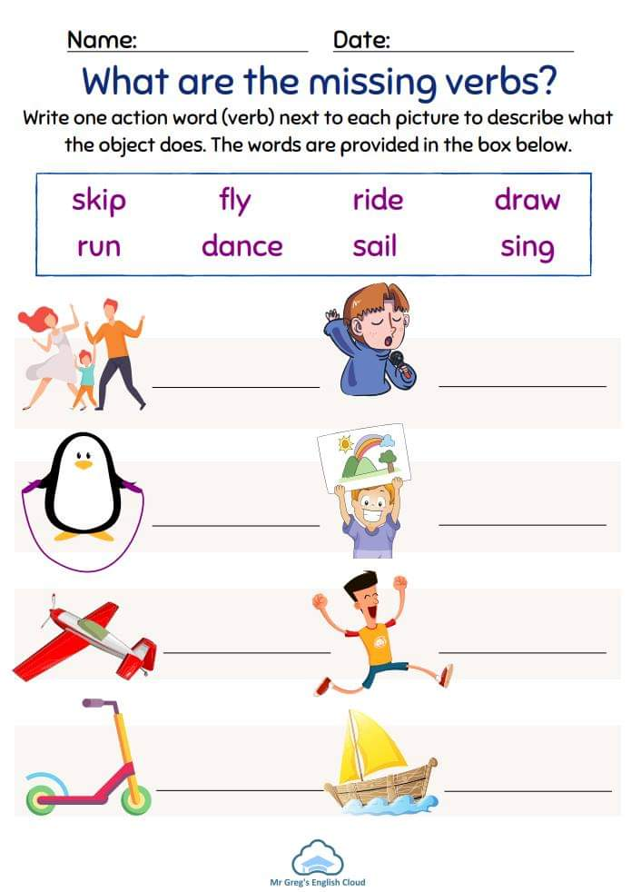

**Наприклад**: sing song, dance with parents

(співати пісні, танцювати з батьками)

1. ***Reading***. (прочитайте казку з підручника)

Ex. 1 p.26

( ось ця казка, якщо немає електронного підручника)

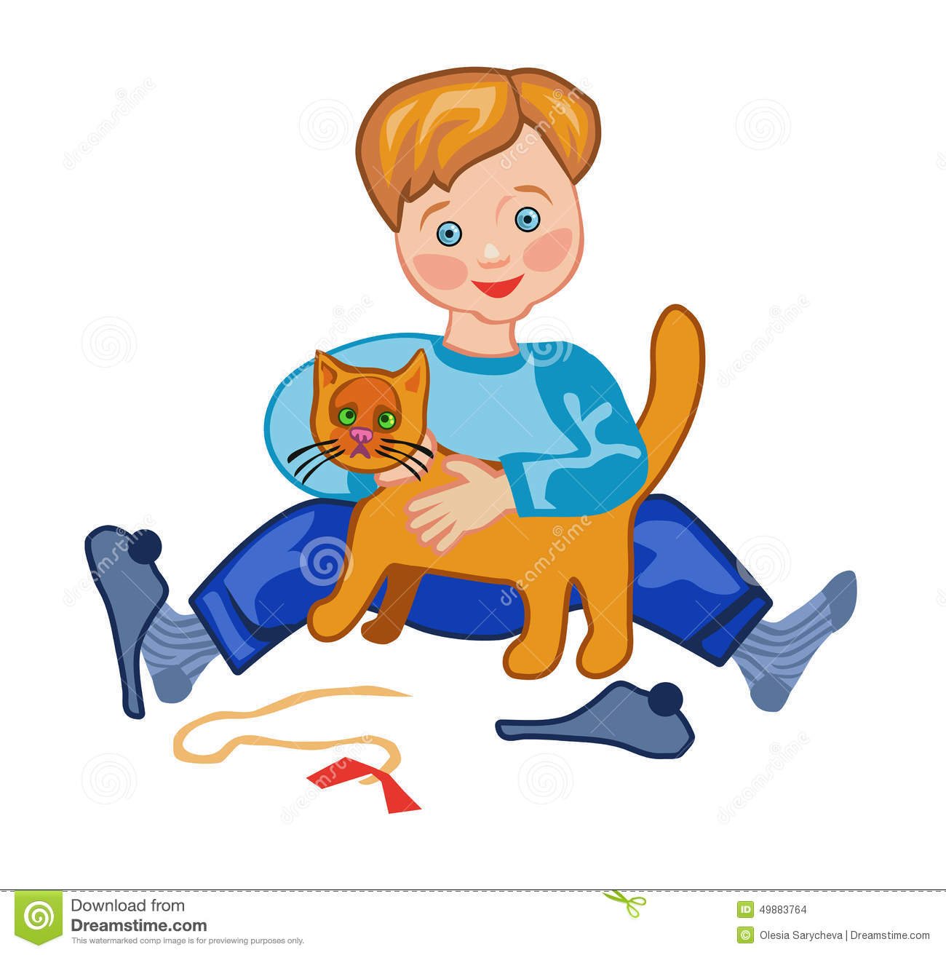

*Once upon a time, there was a poor boy Dick Whittington. The people in his village said that the streets of London were made of gold. Dick went to London. Dick walked for many days, but when he came to London, the streets were not made of gold! He fell asleep on the steps of a great house. A rich businessman found Dick and gave him a job in his kitchen. Dick worked very hard and was happy. He had food and slept by the fire. At night, rats ran around the kitchen. Dick couldn’t sleep. So, Dick found the fastest cat in London! The cat caught all the rats, and Dick could sleep at night. The businessman took the cat to catch rats on his ship. Dick was very sad. The cat was his friend. Dick ran away. The great church bells rang, ‘Turn back, Dick Whittington, the Mayor of London!’ Dick came back to the house. The businessman gave Dick and his cat a lot of money for their help. Dick worked hard. He married the businessman’s daughter,*

*started a very big business. And, yes, he became the Mayor of London!*

**Home work**: Шановні діти, опрацюйте конспект уроку.

* Складіть словосполучення і запишіть у зошит
* Прочитайте казку
* Письмову роботу чекаю на Human.